  CDSS Prediction Model Development  A Structured Brief explanation of how the prediction machine learning model was developed | Abstract  This document provides a clear explanation of how the CDSS prediction model was developed, including diagram, and all the information and sources.  Nkanini, Avela, (Mr) (s225256797)  ITPV302

Table of Contents
Table of Figures 2
Introduction 3
Machine Learning Model 4
XGBoost (Extreme Gradient Boosting) 5
FastAPI + XGBoost Integration 7
References 8

Table of Figures
Figure 1.1: A diagram showing how the decision tree functions………………………………5
Figure 1.2: A diagram showing how the decision tree functions. ……………………………5
Figure 1.3: A diagram showing the FastAPI connects with the Applications. ……………7

Introduction
This project focuses on developing a Clinical Decision Support System (CDSS) designed to assist oncologists and healthcare providers in the early diagnosis of cancer. Through our research, we identified that delay in diagnosis remains one of the most critical challenges in cancer care, often leading to poor patient outcomes due to late detection.
To address this issue, our team decided to design a Clinical Decision Support Web System specifically tailored for cancer diagnosis. The system aims to accelerate the initial stages of cancer assessment—such as symptom collection, physical examination, and diagnostic testing—by leveraging machine learning to analyse patterns in patient data, symptoms, and cancer types.
The ultimate goal is to create a system that processes patient symptoms and examination results to predict potential cancer types. These predictions would then guide oncologists in selecting appropriate diagnostic procedures, such as CT scans or radiation assessments, in line with established clinical guidelines.
After evaluating various approaches, we concluded that the most effective solution to achieve this goal is to develop a machine learning model capable of interpreting symptom data and generating accurate predictions of possible cancer types.

Machine Learning Model
Cancer diagnosis involves multiple procedures such as analysing a huge range of symptoms that can overlap across multiple cancer types (Clinic, 2025). Since these symptoms and cancer categories are numerous and complex, trying to match them manually to possible cancer types can be time-consuming and prone to errors. To address this challenge, we chose to use Machine Learning (ML) techniques to assist in identifying potential cancer types based on patient symptoms.
Machine Learning was selected because it allows systems to learn patterns from date and make predictions without being explicitly programmed (IBM, 2025). This is going to be very helpful in solving our problem, it will help the system recognize how specific combinations of symptoms are related to certain cancer types. This was going to be difficult to achieve through manual programming methods.
To gain foundational understanding of ML concepts, we began by developing a simple regression model. This first step helped us to understand and learn how a model is trained and how it works. Once we understood the basics, we extended our approach to more advanced algorithms that can handle complex and multi-class classification problems.
After researching different ML methods, we discovered that XGBoost (Extreme Gradient Boosting) is one of the most effective algorithms for structured data classification tasks. We found out that it well known for its high accuracy, speed, and ability to handle imbalanced datasets, this makes it well-suited for our problem where we have multiple cancer types that must be predicted from diverse symptom data (Nvidia, 2025). Therefore, we chosen XGBoost as the core algorithm for our cancer prediction model

XGBoost (Extreme Gradient Boosting)
XGBoost is a powerful and efficient Machine Learning algorithm based on ensemble learning technique called boosting (Nvidia, 2025). In this approach the model will create a series of smaller models know as decision trees, where each new tree learns from the mistakes made by previous trees (Nvidia, 2025).
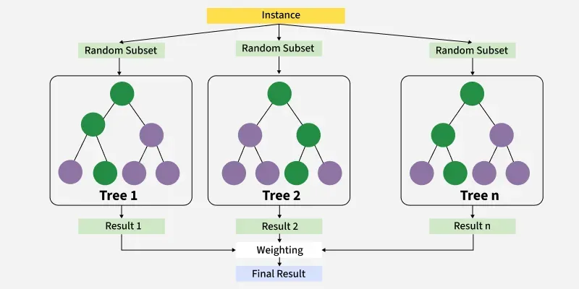
Figure 1.1: A diagram showing how the decision tree functions.
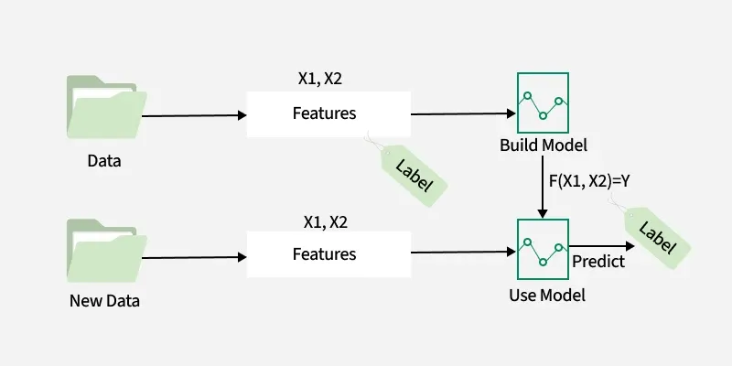
Figure 1.2: A diagram showing how the decision tree functions.

In our project, XGBoost was trained using dataset that contained cancer types and corresponding symptoms. Each symptom was treated as an input feature, and the cancer type served as the output label. The algorithm learned which patterns of symptoms are mostly commonly associated with specific cancer types. During training the XGBoost assigns weight to each symptom and continuously adjusts them through multiple boosting rounds to reduce prediction errors.
When patient new symptoms are entered into the system, XGBoost uses the knowledge it gained during training to calculate the probability of each cancer type. The output is ranked in a list showing which cancers are most likely to be associated with the given symptoms and their probabilities. These predictions help oncologists and healthcare providers focus on the most likely conditions first, improving decision-making and saving time during diagnosis. Another reason we chose XGBoost for building the model was its ideal speed and scalability. It can process large number of symptoms efficiently, handles missing data, reduce overfitting, this makes it more suitable for real world healthcare data that is often incomplete.

FastAPI + XGBoost Integration
When we were done with building and training the model, we needed an efficient way to make it accessible to other systems, such as our clinical website. For this purpose, we did research and found out that FastAPI was our solution for integrating our model to our backend. FastAPI is a modern Python framework designed for building high-performance APIs fast and efficiently. It is lightweight, easy to use, and has support documents (Ali, 2022).
FastAPI is a bridge between the trained XGBoost model and external users. When a user (such as oncologist or patients) submit symptoms through the website interface, FastAPI receives this input as a JSON request. The API then processes the input and sends it to the XGBoost model for prediction. The model returns a list of possible cancer types with their associated probabilities, and FastAPI responds with a structured JSON output that can be easily displayed on the web interface. This design makes it easy to update or retrain the XGBoost model in the future without changing the entire backend structure.
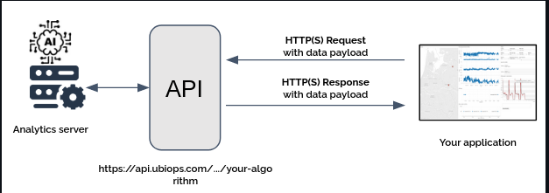
Figure 1.3: A diagram showing the FastAPI connects with the Applications.
Overall, combining FastAPI with XGBoost model allowed us to build a fully functional prediction API that is not only accurate but also fast, scalable and ready to be integrated into healthcare environments.

References

Ali, M. (2022, September 26). FastAPI Tutorial: An Introduction to Using FastAPI. Retrieved from datacamp: https://www.datacamp.com/tutorial/introduction-fastapi-tutorial
Clinic, M. (2025). Cancer. Retrieved from mayoclinic.org: https://www.mayoclinic.org/diseases-conditions/cancer/diagnosis-treatment/drc-20370594
IBM. (2025). What is machine learning ? Retrieved from IBM: https://www.ibm.com/think/topics/machine-learning
Nvidia. (2025). XGBoost. Retrieved from Nvidia: https://www.nvidia.com/en-us/glossary/xgboost/#:~:text=XGBoost%2C%20which%20stands,new%20dataset%E2%80%99s%20features.

